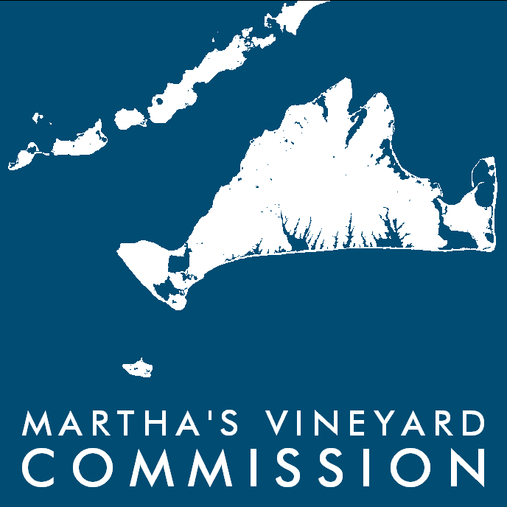
Martha's Vineyard Commission
Staff Housing Sub-Committee Meeting
Date: June 21, 2017 1:00PM
Place: The Mansion House
Library
Check for updates on the website calendar: www.mvcommission.org

AGENDA

- Decide on regular meeting schedule
- Recap work that has been done on project previously
- Discuss who to use as agent
- Outline administrative guidelines for staff housing
- Create accurate phone list and distribute to all committee members

